Following are the settings to configure Git hub central repository with the Jenkins so that tests can be run in Jenkins by invoking repository code in git hub.

**Step 1:** First of all we have to install the git.exe. Once it is installed, the exe will get placed in the following location.

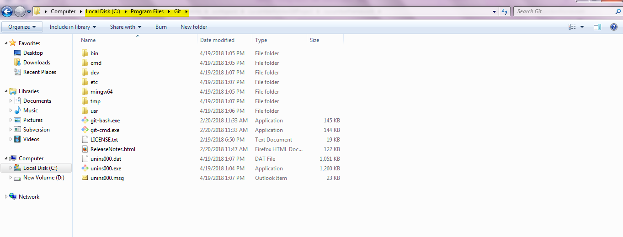

Step 2: Now open Jenkins and navigate to ‘Manage Jenkins’🡪 Global tool configuration

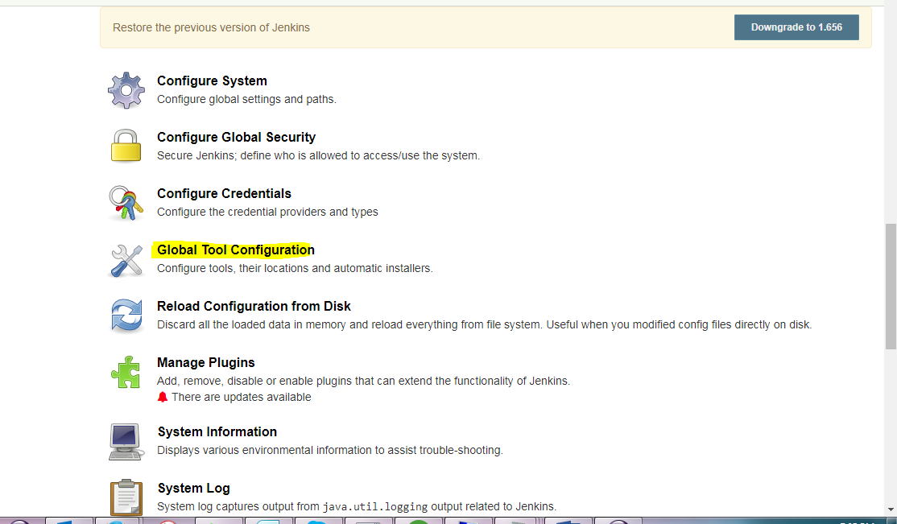

Step 3: Click on ‘Global Tool Configuration’ and set the following settings.

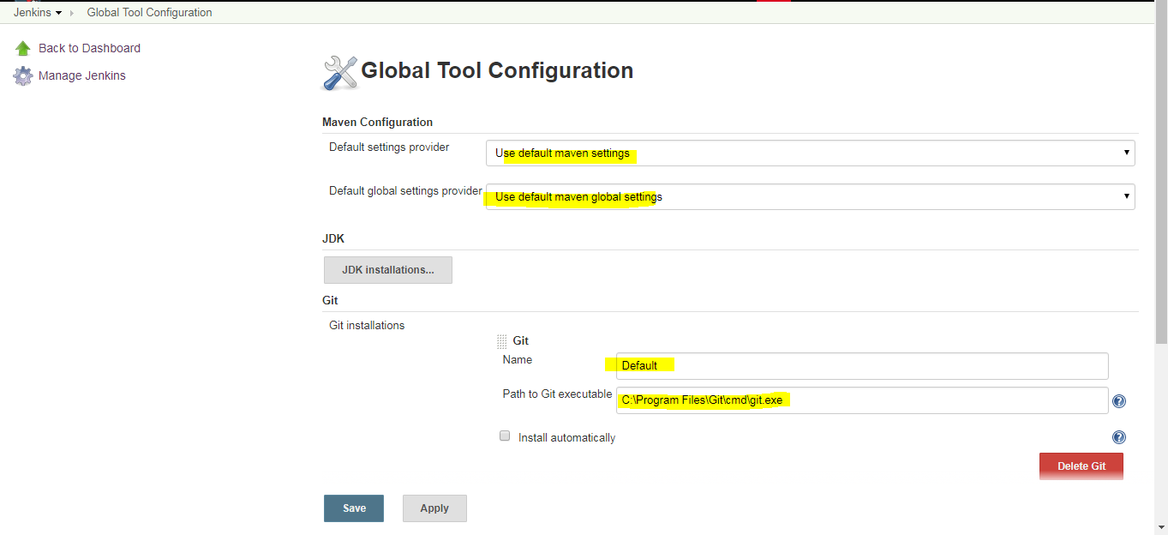

Step 4: Now navigate to Manage Jenkins 🡪‘Configure system’ and set the following settings:





Navigate to Manage Jenkins🡪 Available tab and installed the following git plugins.

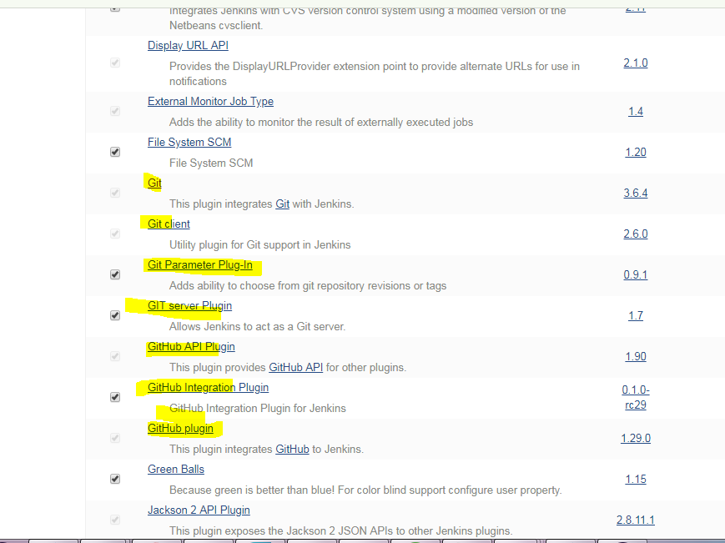

Step 5: Click on ‘New item’ and enter project name and select Maven project.

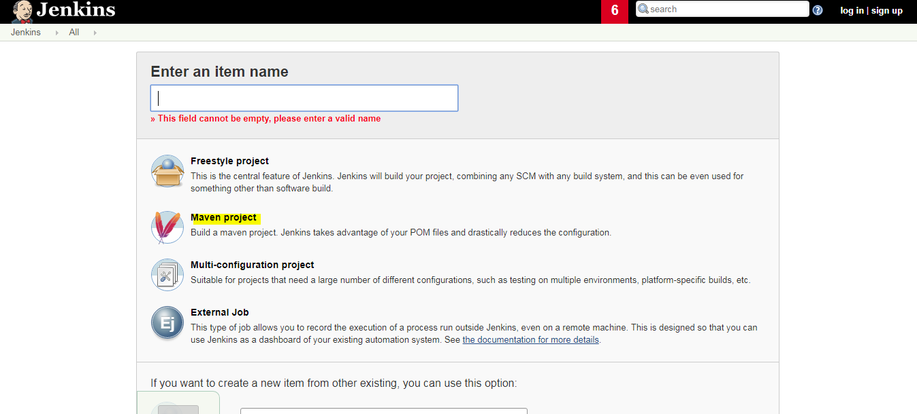

Step 6: Created project will be created in below screen:

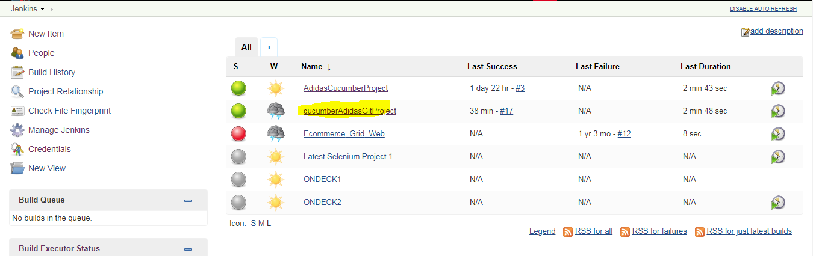

Step 7: Click on project name and then click on ‘configure’ link.

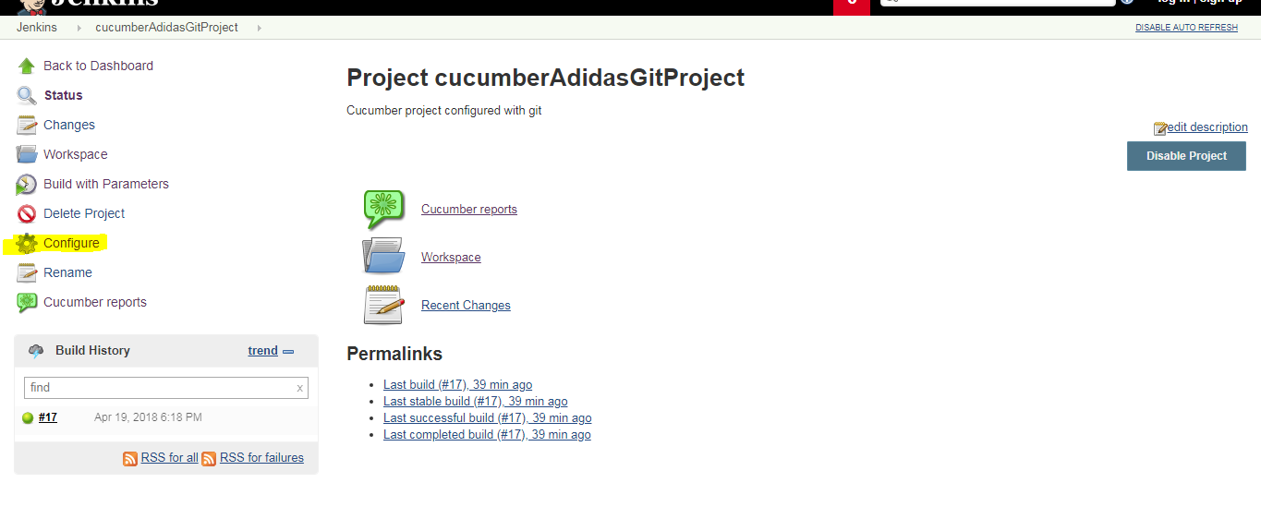

Step 8: Now configure the following highlighted configurations.

Note: For ***git parameters***, we have to install git parameter plugin. Otherwise, this option will not be shown.

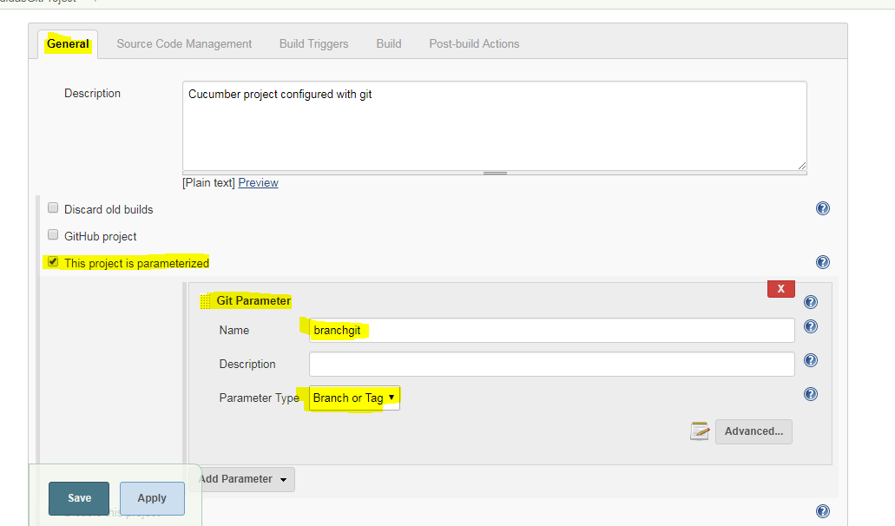

Here , the credentials should be the credentails of git hub credentails.

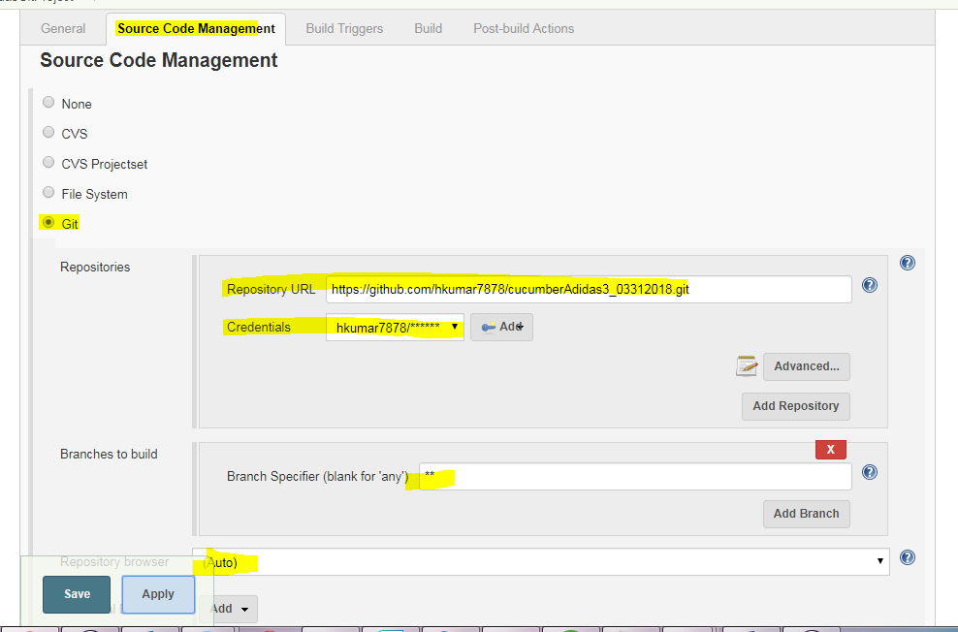

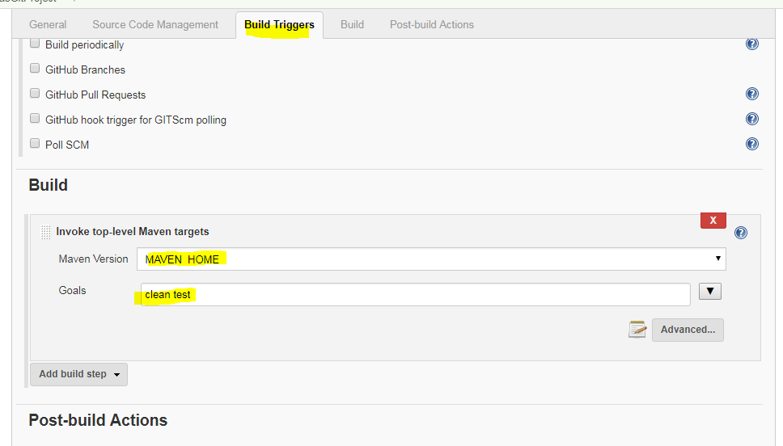

Or

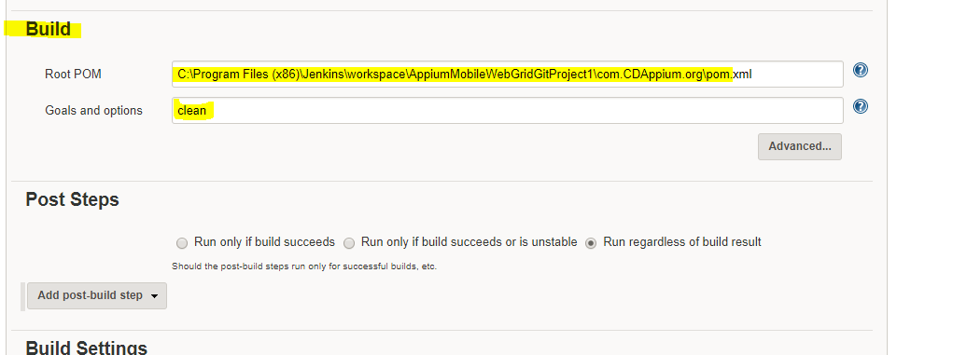

Step 9: Click on apply and save button.

Step 10: Now, this is time to build this project so that test cases can be run.

Step 11: Click on project link:

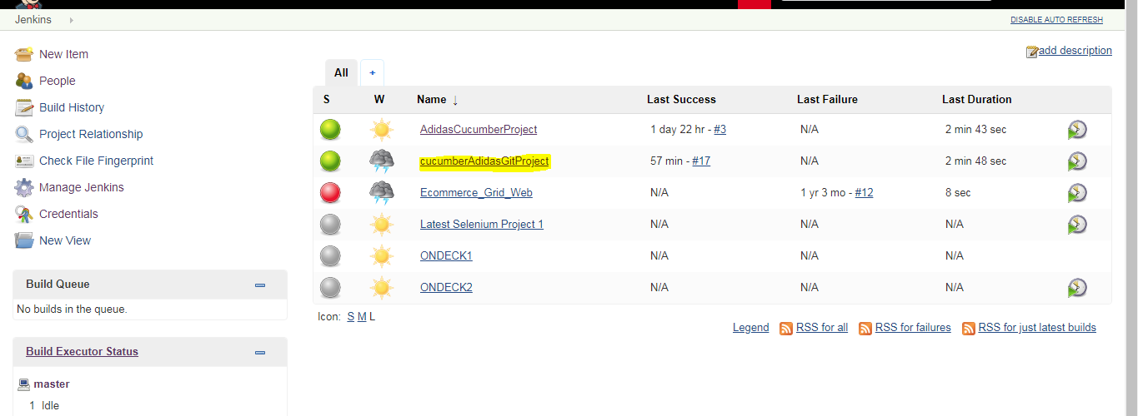

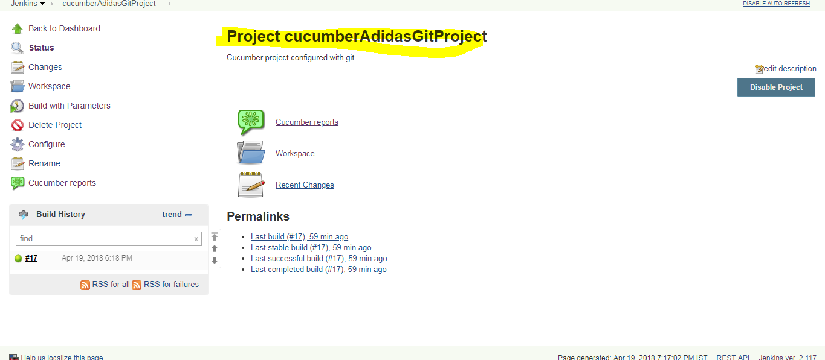

Step 12: Now click on ‘Build with parameters’ link. After clicking it, the following page will be displayed. Select first entry and click on ‘Build’ button.

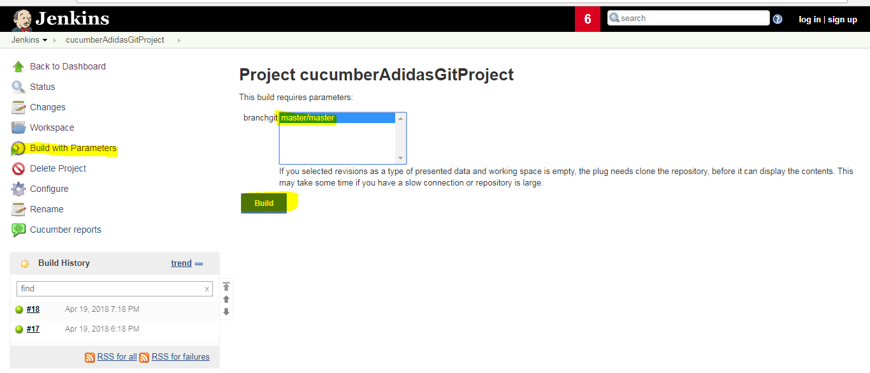

After clicking on build button, project will be built and tests will be run. Check the console output for success message.

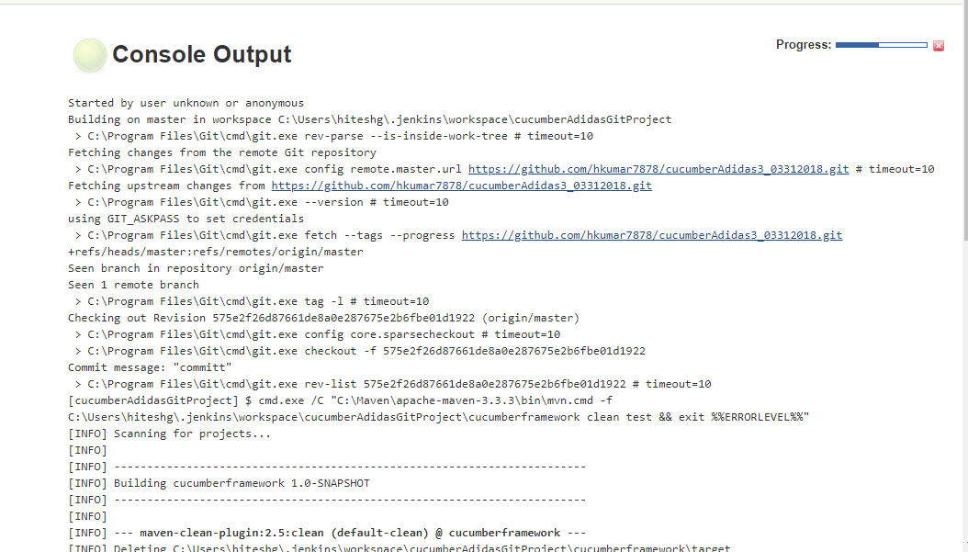

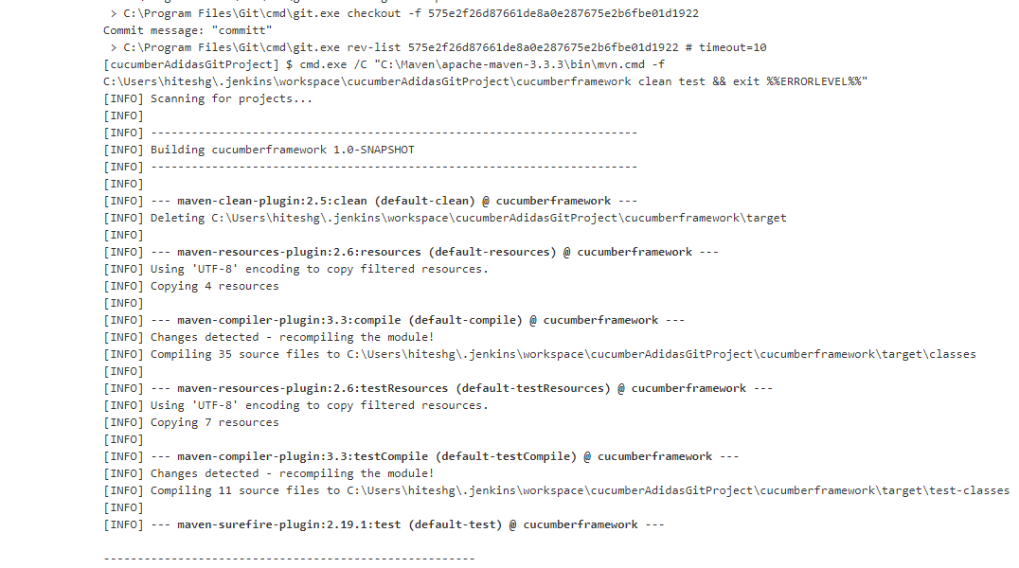

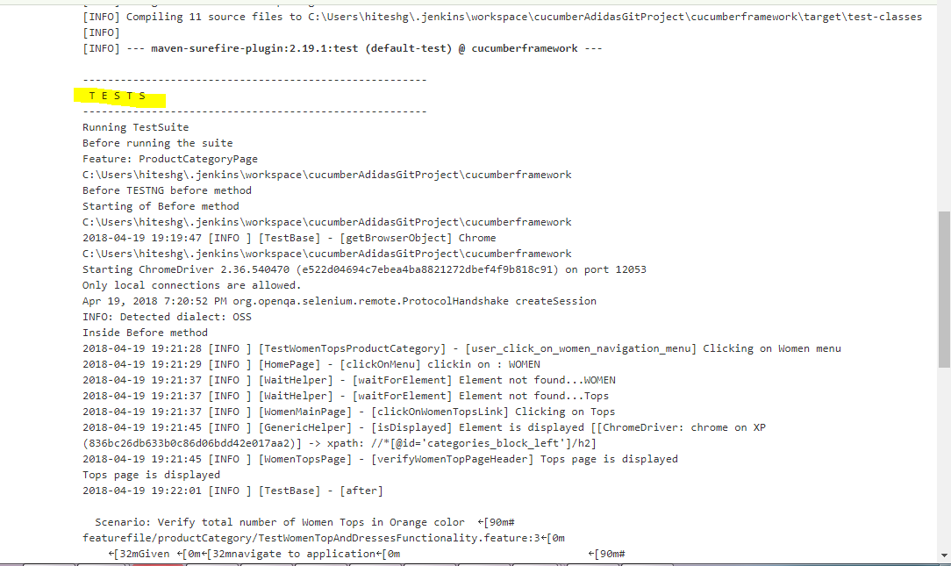

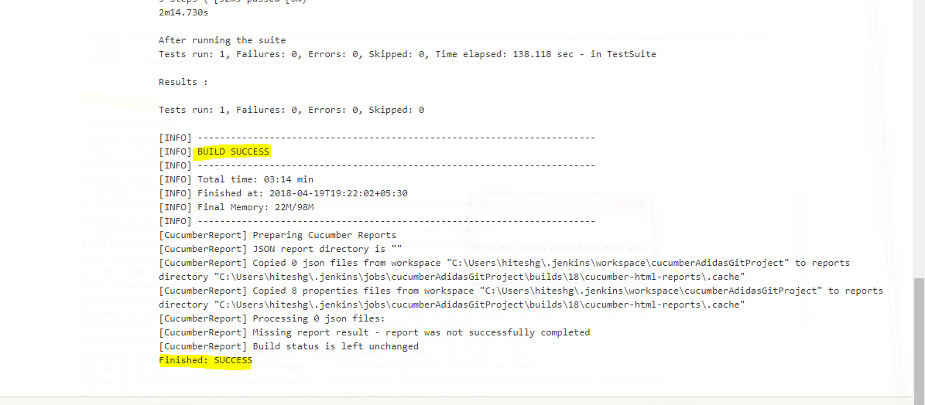

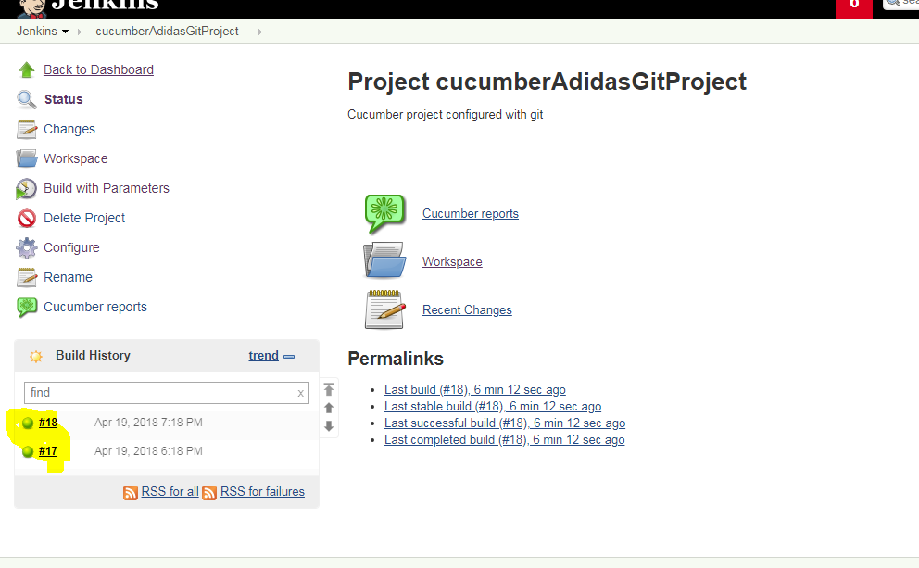

Note: It may be possible that sometimes, build got failed to get triggered as Jenkins did not detect any changes in git central repository. In order to overcome this, just make some changes in code in eclipse, commit and push to central repository and then built a project in Jenkins.

Note: Git project should be visible in the following Jenkins location once all above settings are done

